1. 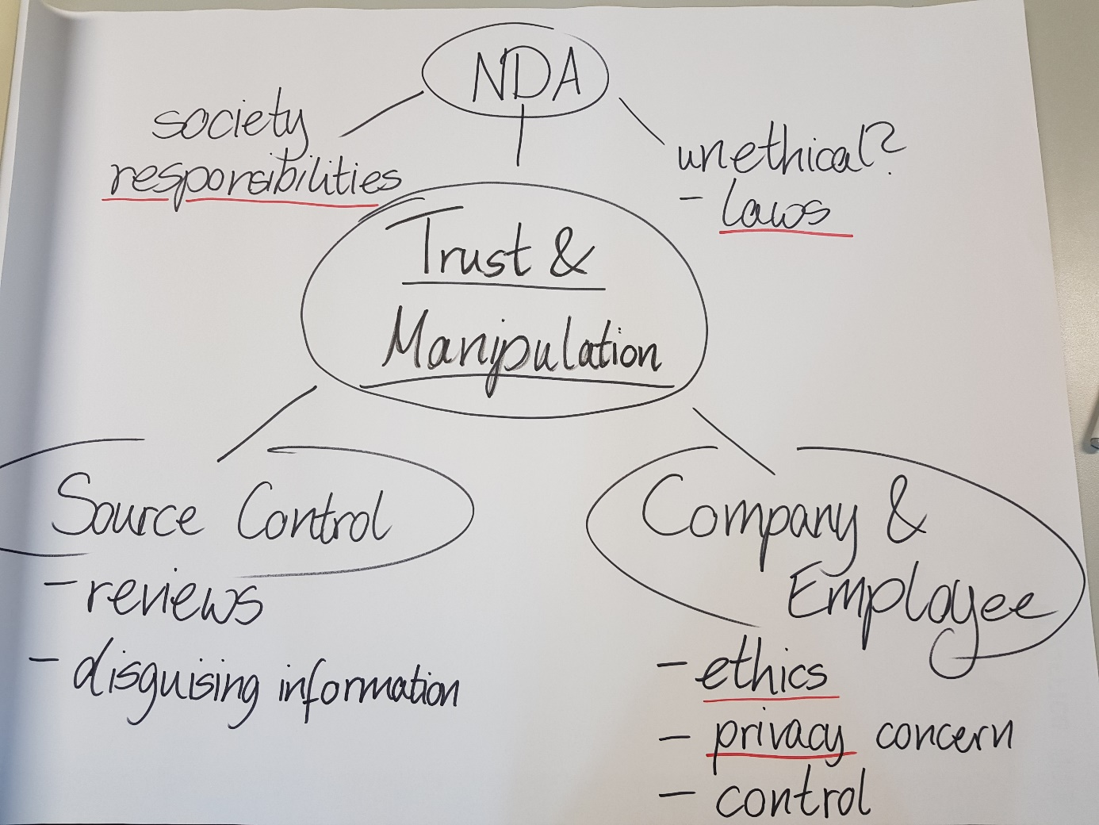Ethical Software Engineering

|  |  |  |
| --- | --- | --- |
| 2018-10-15 | Info 3  Lab Report | Johanna Spaude, Sao Chi Pham,  Florian Murzov-Pirkl |

We chose the "Fallbeispiel: Manipulation" (Link: <http://gewissensbits.gi.de/fallbeispiel-manipulationen/>). It is about the employee Achim of the company "AlgoConsult", working on a project called “CompanyRate”. This program rates companies operating in Germany, which is made for the banking sector, helping them on making decisions for their investments. The first beta version of the project was followed by a positive resonance.

Achim listens secretly to a phone call of a colleague. Afterwards, he suspects him to work for the "People’s Fruit Company", and on the next day, Achim finds new code of his colleague in their program, which he found out, is good for the "People’s Fruit Company". The colleague wrote a lot of other documentation code. The employee does not know if the colleague is really illegally interacting with the "People’s Fruit Company" and just wrote the new code to hide the suspicious one. Weeks ago, another colleague got fired because of something strange and still does not want to talk about it. Achim feels something strange is going on and is in a dilemma right now.

Our discussion was about trust and manipulation in this example. We noticed that this project could have a big impact on the economy, because investors from the banking sector started to trust it. If a company gets a higher ranking from the algorithm, its odds of getting more investments will increase. Therefore, the interest of manipulating the algorithm towards one’s own advantage rises likewise.

First of all, the algorithm of such an enormous importance always needs to get reviewed by someone in our view. Since the project holder has business interests in hiding the algorithm, because it is (or seems to become) the main product for making their profit, at least internally in the company, it is obligatory that the code must be checked. Thus, it is absolutely all right, that all the changes were analysed, even if there was no suspicion at all. We also suggest that software with a high influence on the lives of many people (in this case the potential to harm other companies and its people economically), shall be inspected by a governmental or independent institution if there is some kind of reasonable proof, in order to reduce the possibilities of manipulation.

Working together in a project automatically means that all people in this project have to review the code. At least everyone has to understand why someone did something in the code and what effect it could have. Otherwise they may be doing something twice or even something that conflicts with each other. The documentation of the company code must be very clear in this case. In a company you program for the company and not for yourself. So, it is not about privacy or keeping secrets. Reviewing code of colleagues is a good workflow. The employee in our story did nothing wrong when looking through the changes. That way the source control systems keeps track of important changes.

Moreover, every employee had to sign an NDA (non-disclosure agreement) as part of the contract. It is not clear from the text, if each employee had to sign the same NDA.

Of course, an employee must work for the company and sign an agreement that this person will not harm the company. However, the NDA is always a very difficult topic, which is why our opinions differed in some aspects. Imagine there is something illegal written in the NDA. Could you do the illegal activities without questioning? Would it be OK to go against the law for your company for a lot of money?

Not talking about the final product before the public release is not a hard thing as it is a very common practice. Nevertheless, when someone does something against the law it should not be covered by an NDA or protect the company. However, here our opinions diverged. On one hand, one should talk about infringement to someone, on the other hand one would be labelled as “whistle blower” maybe which could result in fewer job offers and this would go against the contract. The only right thing one can do is getting a lawyer before signing the contract.

Another topic was the actual behaviour of Achim when he had realised his colleague was having a conversation with someone on the phone but still overheard him in secret. We agreed that we disagree in this point as this was depending on the view of the individual. In a way it was super rude overhearing the colleague regardless of the content of the conservation. However, while everyone needs privacy, there are different ways to accomplish them. On one hand private matters should stay at home, on the other hand some privacy space in company should exist. In a big busy office room, it is normal when other people listen to other conversations which is where we agreed. So, in a sense Achim in our example did nothing wrong when he listened to his colleague. If there is something that no-one should hear, the colleague should have gone into a room where nobody can walk in (or listen) easily through the door. Though, Achim could have made himself noticeable as he knew that his colleague was inside.

Furthermore, if you work for a company, it could be seen as duty to report something like this, especially when being in a room with many people, one should act like the company wants one to act. Since especially this project has such a powerful potential of influencing the economy, it is probably even more understandable being or becoming suspicious about the strange behaviour of other people, who are involved in this project. Even good colleagues with high ethical standards may be in danger of getting manipulated by other companies, for example through bribery, because the whole business is about a lot of money.

What is considered as an ethically right decision varies from person to person. For example, a person who is regarded as someone with generally high ethical standards but at the same time that particular person might think accepting a huge check is alright if the money is used for other good causes. From the point of view of this person it is seen as “the right thing” because the money was from someone rich and given to the poor. But such a decision might be short-sighted, because the negative impact could be much bigger than the positive one, especially in a long term. So, who can you really trust in such an environment? Maybe not even your boss. And can you be mad at someone, who suspects you, because they want to ensure the project (of such an impact) does not get sabotaged? Working on a project like “CompanyRate” brings high responsibility and that might not be clear to everyone. People could look at it as opportunities for doing something great in different, maybe even wrong ways. Everyone has their own agenda which can be dangerous.

At the end, regular discussions about the transparency of the company and what it means, and about ethical questions could be helpful to make it clear to everyone, what kind of behaviour is acceptable and what is not. When things are unclear to everyone, dilemmas like the ones from our story will appear eventually. It is not enough to just assume (as the boss or project manager) that everyone is on the same page because everyone signed a contract. The employees are left to their own decisions and judgements and start to act on their own behalf which is toxic to the working environment.

In addition, just as there are strict controls and guidelines about code, there must be for employees and managers for guaranteeing the quality of the product and way of behaving. It should never be tempting to even make a single try to cheat. This way employees, especially people in lower positions, have ways to communicate about problems without fearing bad consequences and keeps everyone open-minded and friendly with each other. However, that means that there must be systems beforehand in case of abuses, meaning that the boss of a project or even someone higher cannot have the absolute power. This is something difficult and probably requires full investment from the company to create division of powers.

Time needed for this lab: we needed the time in the lab plus one hour each to write this report.